Assignment- 3
Name: Neha Shiv
Student ID: 225751105
UNIT- Real world Analytics (SIT718)

Q.1) a. Why Linear Programming is Appropriate
- The quantities for product A and product B are continuous and not discrete. This allows factory to find the exact fractional blend required to minimize the costs.
- The objective is to minimize the total cost of production, and this cost changes directly with the amount of each product used, making the objective function linear.
- It is seen that any change in the input of products results in a proportional change in both the total cost and the concentration of the juice ingredients. Making the equations linear.
- The total volume and final cost are the sum of individual contributions from A and B. making it viable to choose a linear model.
- The model assumes that the 'impact' of each item remains the same whether we produce a small batch or a massive one. Since the cost per unit and the nutrient contribution don't fluctuate based on volume, the mathematical relationships remain a straight line (linear), ensuring the results are predictable across the entire production range.
b.) Objective function: Z (min) = 4x1+12x2
Constraints: 1.) 2*x1+7*x2<= 6*(x1+x2)
2*x1+7*x2 <= 6*x1+6*x2
- 4*x1<= - x2 (multiply – on both sides)
4*x1 ≥ x2
2.) 6*x1 + 4*x2 >= 5*(x1+x2)
6*x1 + 4*x2 >= 5*x1 + 5*x2
6x1-5*x1 >= 5*x2 - 4*x2
x1 >= x2
3.) 4*x1+8*x2 >= 5*(x1+x2)
4*x1+8*x2 >= 5*x1+5*x2
4*x1-5*x1 >= -8*x2-5*x2
-x1 >= -3*x2 (multiply – on both sides)
x1<= 3*x2
x1+x2>=140
x1>=0
x2>=0
Therefore, the constraints are 4*x1>= x2, x1 >= x2, x1<=3*x2, x1+x2>=140, x1>=0, x2>=0

c.
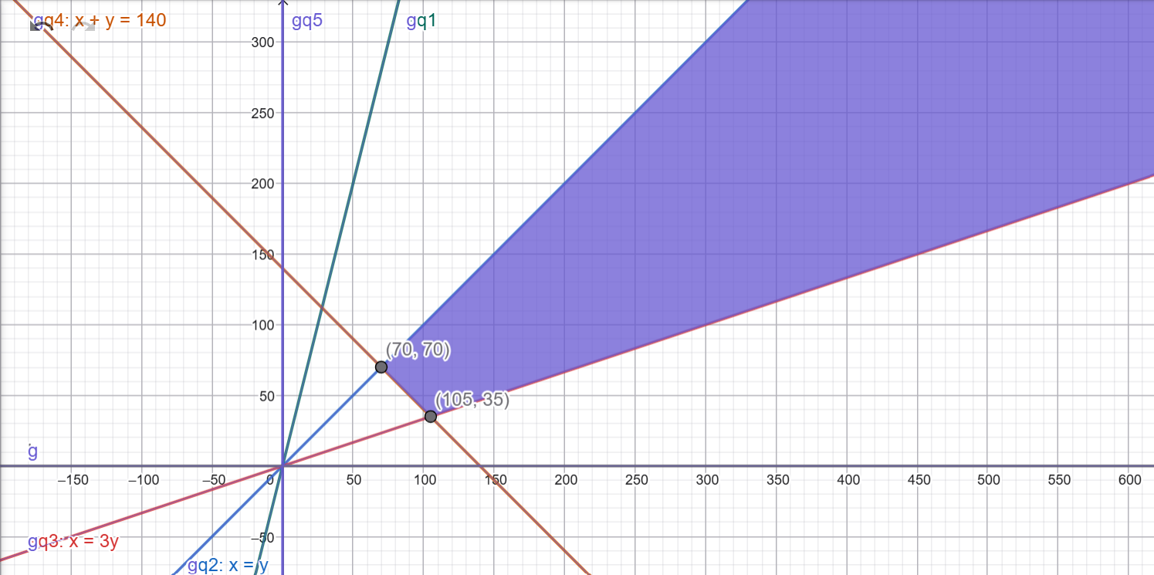 Solution: The feasible region is unbounded, the corner points are (70, 70) and (105, 35)
- 4*(70)+12*(70)=$1120
- 4*(105)+12*(35)=$840
So, the optimal solution of z is $840 for (x,y) = (105, 35).

- For the optimal solution to stay the same, the slopes of the objective function has to lie between the slopes of the two constraints.
Equation of the two slopes
- x=3*y
y=x/3 -> slope=1/3
- x + y=140
y=140-x -> slope =-1
Equation of the slope for the objective function
Z=A*x+12*y
12*y= z-A*x
y = (z/12) - (A*x/12) -> slope = -A/12

<=> -1<= -A/12 <= 1/3
Multiplying by -12 on b.s
We get, 12 >= A >= -4
- -4<=A <= 12
- Since, cost can’t be negative in the real world. Therefore, 0<=A<= 12.
- So, the range of product A lies between $0 to $12, to get the same optimal value of z.
Q2 In this model, I categorized the requirements as follows.
Let c1, c2 and c3 be the quantity of cotton required for spring, autumn and winter respectively
Let w1, w2, w3 be the quantity of wool required for spring, autumn and winter respectively.
Let s1, s2, s3 be the quantity of silk required for spring, autumn and winter respectively.
- Total profit = total revenue- cost from production – cost from material.
=60*(c1 + w1 + s1) + 45*(c2 + w2 + s2) + 75*(c3 + w3 + s3) – {5*(c1 + w1 + s1) + 4*(c2 + w2 + s2) + 8* (c3 + w3 + s3) + 33*(c1 + c2 + c3) + 46 *(w1 + w2 + w3) + 51*(s1 + s2 + s3)}
=c1*(60 – 5 – 33) + c2*(45 – 4 – 33) + c3*(75 – 8 - 33) + w1*(60 – 5 - 46) + w2*(45 – 4 - 46) + w3*(75 – 8 - 46) + s1*(60 – 5 - 51) + s2*(45 – 4 -51) + s3*(75 – 8 - 51)
Therefore, the objective function is max z = 22*c1 + 8*c2 + 34*c3 + 9*w1 -5*w2 + 21*w3 + 4*s1 – 10*s2 + 16*s3

Constraints:
For spring: cotton
(c1/ c1+w1+s1) >= 0.53
C1>= 0.53*w1 + 0.53*s1 +0.53* c1
C1*(1-0.53) >= 0.53*w1 + 0.53*s1
0.47*c1>= 0.53*w1+ 0.53* s1
0.47*c1 – 0.53*w1 – 0.53* s1 >= 0
For spring: wool
(w1/ c1+w1+s1)>=0.30
W1>=0.30*c1+ 0.30*w1 + 0.30*s1
W1*(1-0.30)>= 0.30*c1 + 0.30* s1
0.70*w1 >= 0.30*c1+ 0.30* s1
0.70*w1 – 0.30*c1 – 0.30*s1 >=0
For spring: silk
(s1/ c1+w1+s1)>= 0.01
S1 >= 0.01*c1 + 0.01*w1 + 0.01*s1
S1*(1-0.01) >= 0.01*c1 + 0.01*w1
0.99*s1 – 0.01*c1 – 0.01*w1 >=0

For autumn: Cotton
(c2/ c2+w2+s2)>=0.47
C2>=0.47*c2+0.47*w2+0.47*s2
C2*(1-0.47) >= 0.47*w2 + 0.47*s2
0.53*c2 – 0.47*w2 – 0.47*s2 >= 0

For autumn: Wool
(w2/ c2+w2+s2) >= 0.40
W2 >= 0.40*c2 + 0.40*w2 + 0.40*s2
W2*(1-0.40) >= 0.40*c2 + 0.40*s2
0.60*w2 – 0.40*c2 – 0.40*s2 >= 0

For autumn: silk

(s2/ c2+ w2 + s2) >= 0.02
S2 >= 0.02*c2 + 0.02*w2 + 0.02*s2
S2*(1-0.02) >= 0.02*c2 + 0.02*w2
0.98*s2 – 0.02*c2 – 0.02*w2 >=0

For winter: cotton
(c3/ c3+w3+s3)>= 0.36
C3 >= 0.36*c3 + 0.36*w3 + 0.36*s3
C3*(1-0.36) >= 0.36*w3 + 0.36*s3
0.64*c3 – 0.36*w3 – 0.36*s3 >= 0

For winter: wool
(w3/ c3+w3+s3) >= 0.50
W3 >= 0.50*c3+ 0.50*w3 + 0.50*s3
W3*(1-0.50) >= 0.50*c3+ 0.50*s3
0.50*w3 – 0.50*c3 – 0.50*s3>= 0

For winter: silk
(s3/ c3+w3+s3) >= 0.03
S3 >= 0.03*c3 + 0.03*w3+ 0.03*s3
S3*(1-0.03) >= 0.03*c3 + 0.03*w3
0.97*s3 – 0.03* c3 – 0.03*w3 >= 0

Therefore the constraints are 0.47*c1 – 0.53*w1 – 0.53* s1 >= 0,
0.70*w1 – 0.30*c1 – 0.30*s1 >=0, 0.99*s1 – 0.01*c1 – 0.01*w1 >=0,
0.53*c2 – 0.47*w2 – 0.47*s2 >= 0, 0.60*w2 – 0.40*c2 – 0.40*s2 >= 0
, 0.98*s2 – 0.02*c2 – 0.02*w2 >=0, 0.64*c3 – 0.36*w3 – 0.36*s3 >= 0
, 0.50*w3 – 0.50*c3 – 0.50*s3>= 0, 0.97*s3 – 0.03* c3 – 0.03*w3 >= 0
, with the non- negativity constraints c1, c2, c3, w1, w2, w3, s1, s2, s3 >=0

SOLUTION

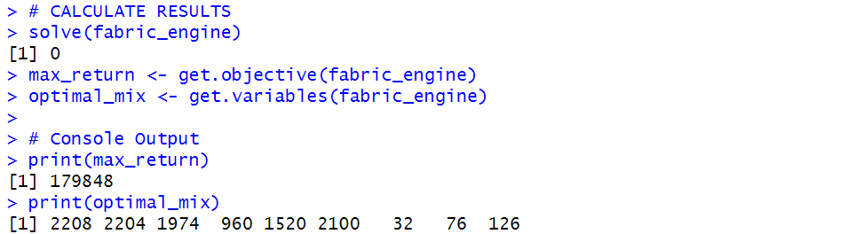

- The maximum profit that can be earned is $179848
- The required quantity of material for each product is
- Cotton for spring is 2208
- Cotton for autumn is 2204
- Cotton for winter is 1974
- Wool for spring is 960
- Wool for autumn is 1520
- Wool for winter is 2100

- Silk for spring is 32
- Silk for autumn 76
- Silk for winter 126

3. A) the payoff matrix for player 1 for the given problem is as follows
 | RWB | RBW | BRW | WRB | BWR | WBR | Row minimum
RWB | 0 | 0 | -80 | 0 | 0 | 80 | -80
RBW | 0 | 0 | 0 | 80 | -80 | 0 | -80
BRW | 80 | 0 | 0 | 0 | 0 | -80 | -80
WRB | 0 | -80 | 0 | 0 | 80 | 0 | -80
BWR | -80 | 80 | 80 | 0 | 0 | 0 | -80
WBR | -80 | 0 | 80 | 0 | 0 | 0 | -80
Column maximum | 80 | 80 | 80 | 80 | 80 | 80

Every row minimum is -80 and maximum value is -80. Every column maximum value is 80 and minimum value is also 80. Therefore, there are no saddle points. We must go with mixed strategies.

b.) LP model for player 1

Objective function: maximize z = v

Constraints: 80*x3-80*x6 + v <=0
-80*x4 +80*x5 + v <=0
-80*x1 + 80 *x6 + v <=0
80* x2 – 80*x5 +v <=0
-80*x2 + 80*x4 +v <=0
80*x1 – 80*x3 + v <=0
X1+x2+x3+x4+x5+x6=1
x1, x2, x3, x3, x4, x5, x6 >=0

Objective function: minimax z = v
-80y3+ 80y6 +v >=0
80y4 – 80*y5 +v >=0
80*y1 – 80*y6 +v >=0
-80y2 + 80y5 +v >=0
80 y2 – 80y4 +v >=0
-80y1 +80y3 +v >=0
Y1+y2+y3+y4+y5+y6 =1
Y1,y2,y3,y4, y5, y6 >=0

Here,
X1,y1= RWB
X2,y2= RBW
X3,y3=BRW
X4,y4=WRB
X5,y5=BWR
X6, y6 =WBR

B=blue, W= white, R=red

Output for player 1: 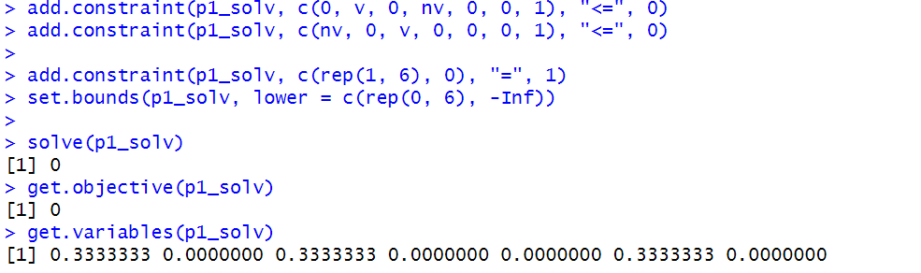

Output for player 2
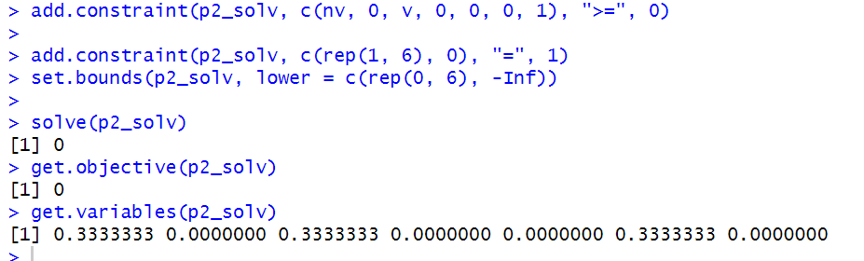

The solver returned the objective function as v=0, which signifies a fair game. That means that the player 1 winning the game = player 2 losing the game. It means that either player has no mathematical advantage.
The optimal strategies for player 1 and player 2 are x1, x3 and x6 and player 2 is y1, y3 and y6. Where x1, y1 is a sequence of RWB, x3,y3 is a sequence of BRW and x6, y6 is a sequence of WBR.
The output shows that each strategy’s sequence should be played with a probability of 0.3333 (1/3).

